**COMPUTER ORGANIZATION AND ASSEMBLY LANGUAGE**

**ASSIGNMENT#02**

**SUBMITTED BY:** HUZEFA SAIFUDDIN - 22K-5125

**SUBMITTED TO:** SIR KASHAN HUSSAIN

**DATE:** 3rd SEPTEMBER,2023

## QUESTION #1:

1. **CODE:**

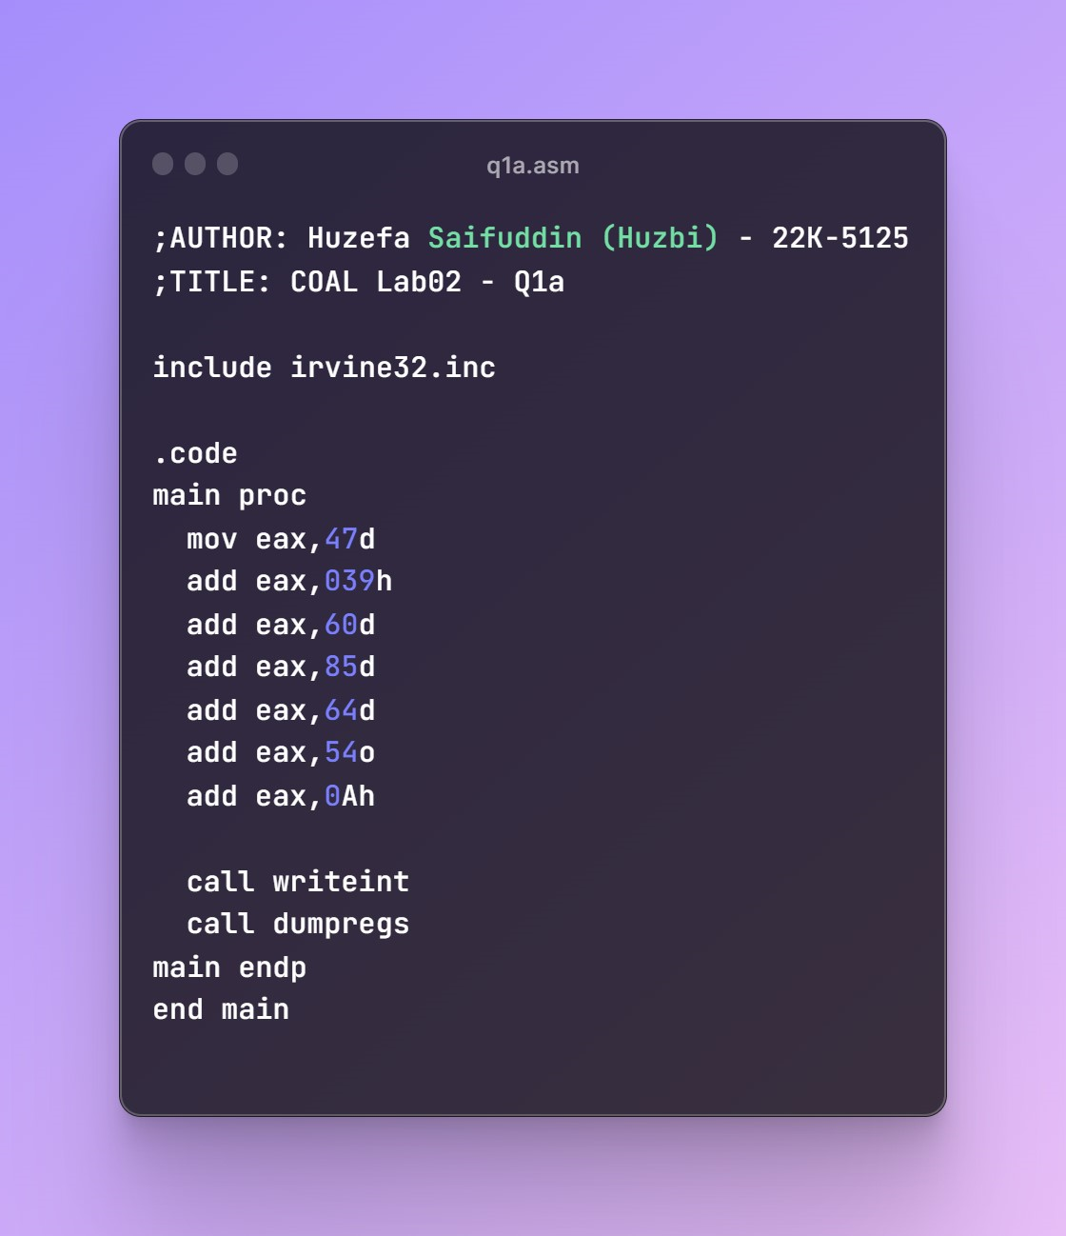

**OUTPUT:**

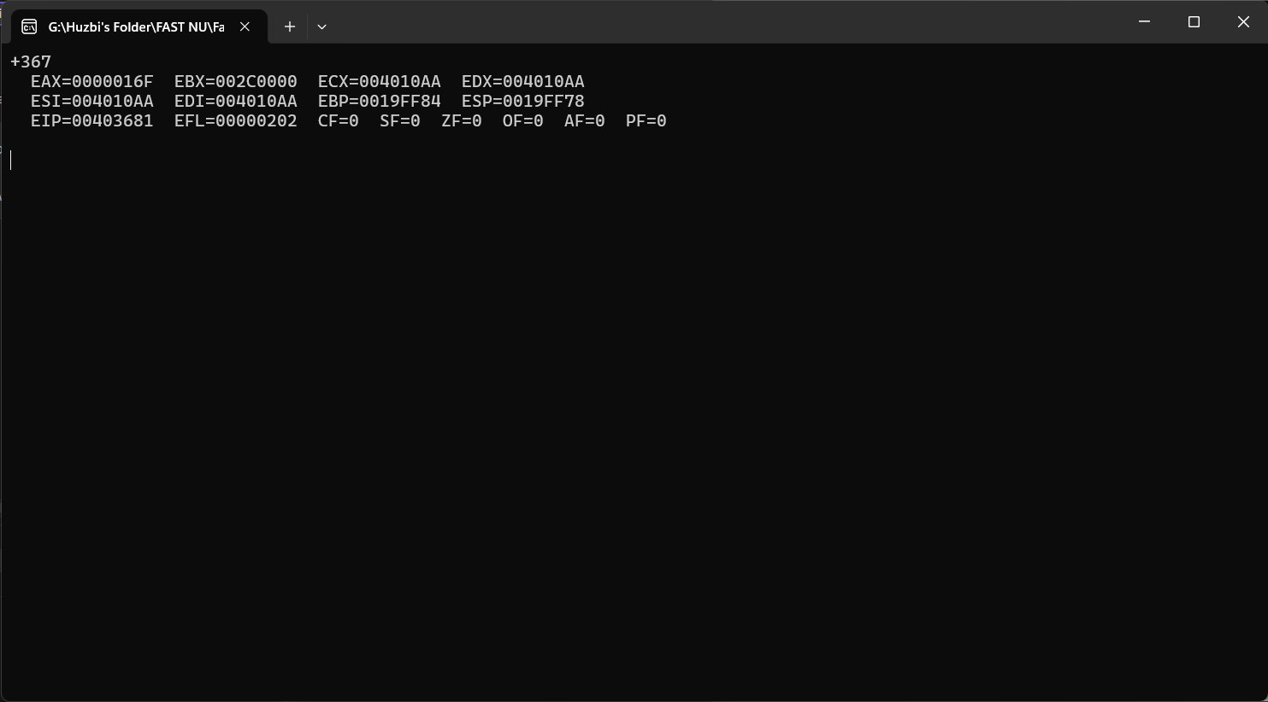

**REGISTER VALUES:**

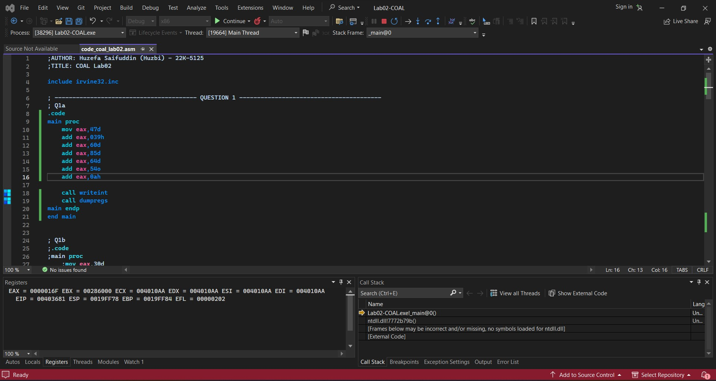

1. **CODE:**

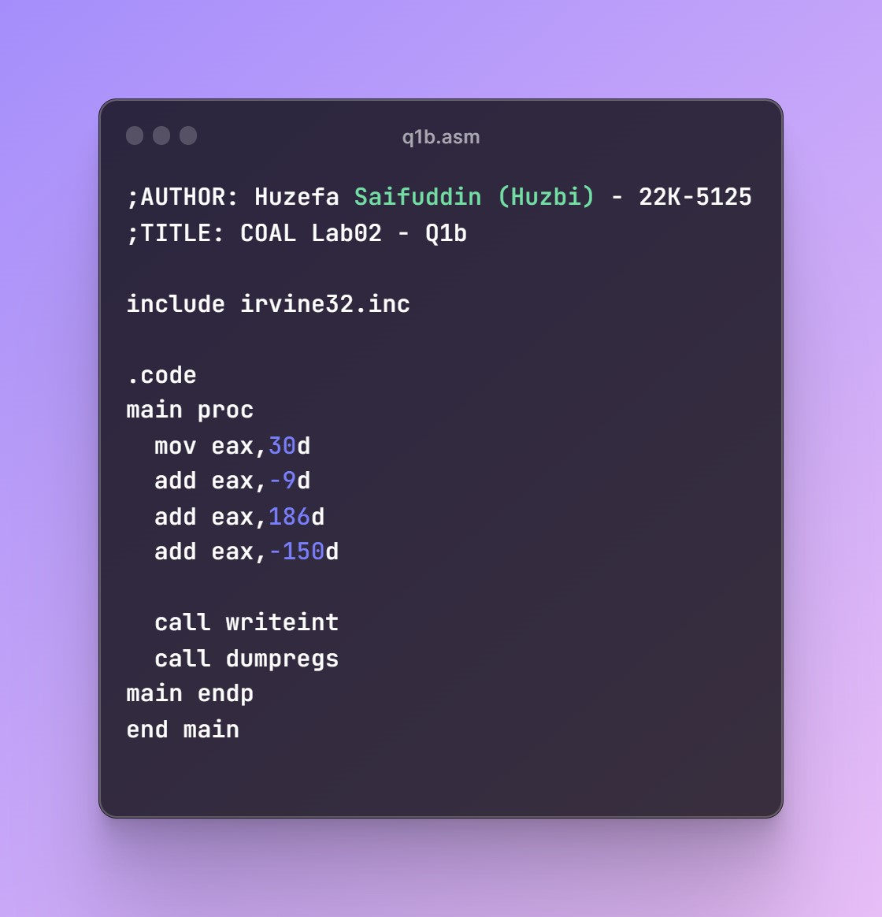

**OUTPUT:**

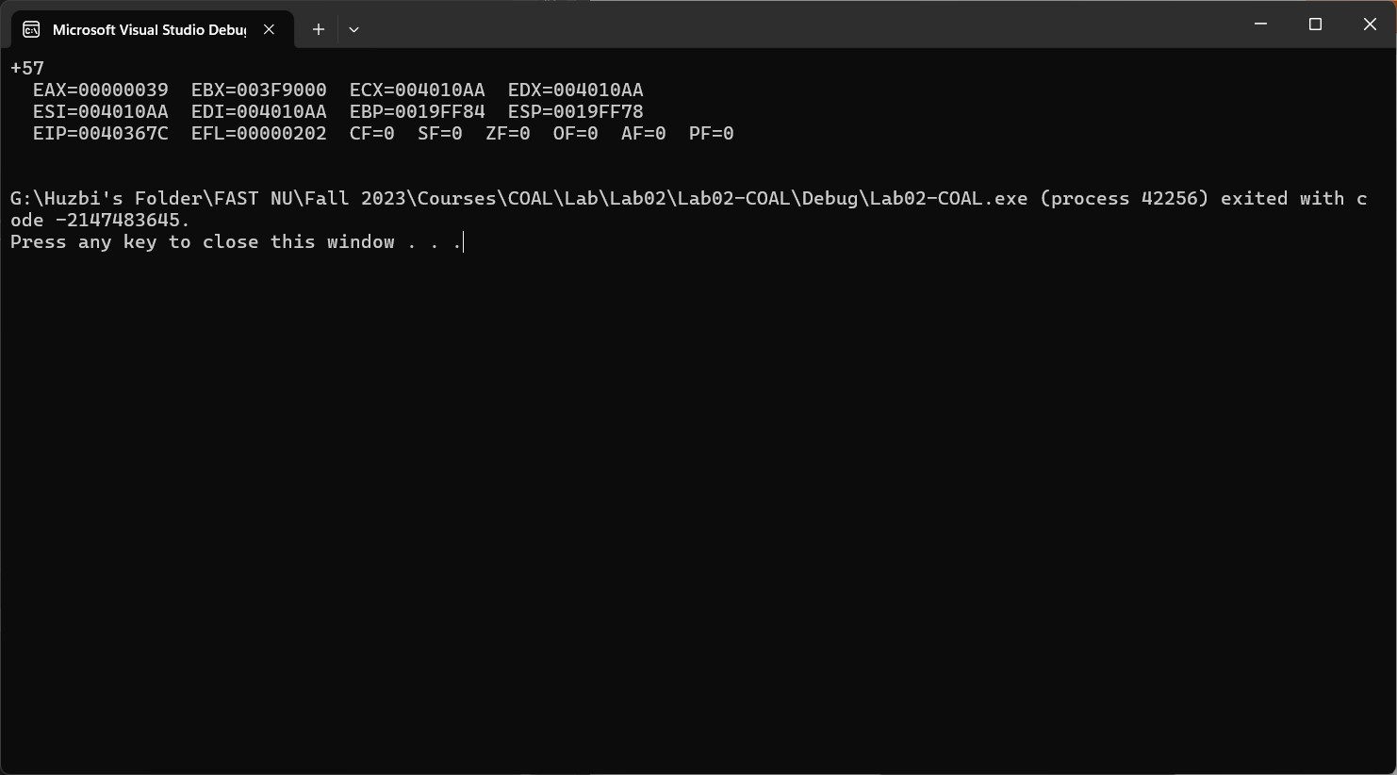

**REGISTER VALUES:**

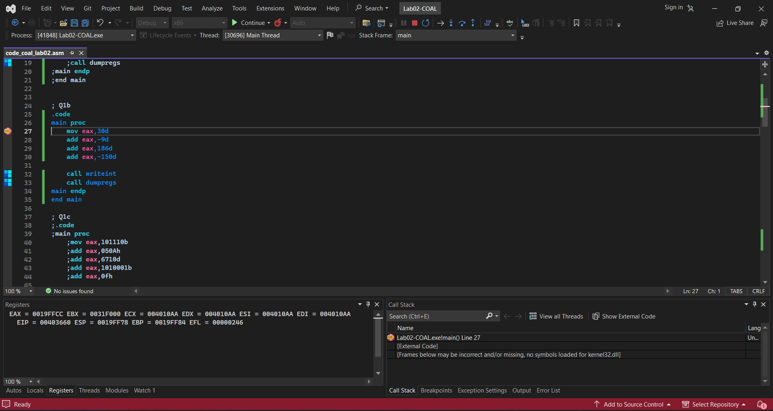

1. **CODE:**

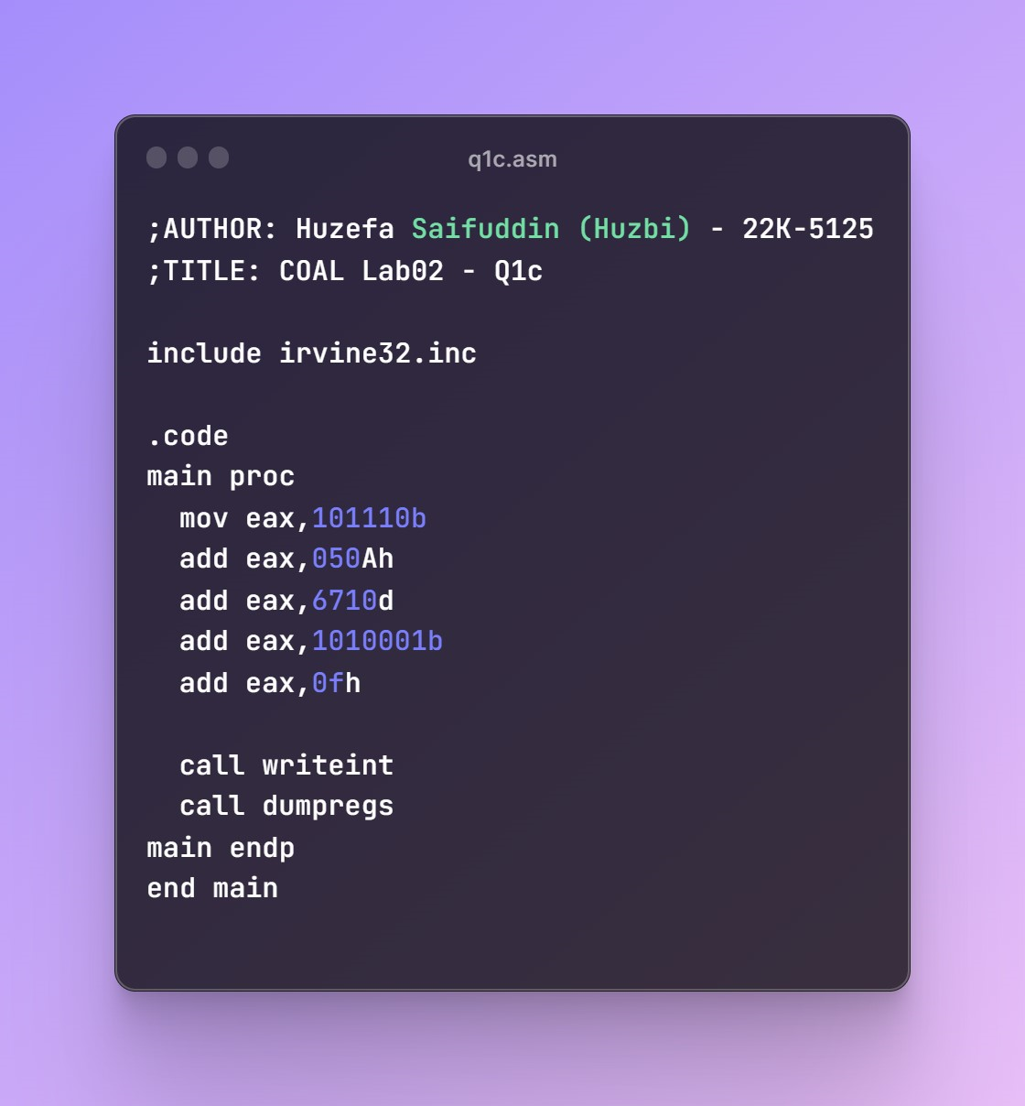

**OUTPUT:**

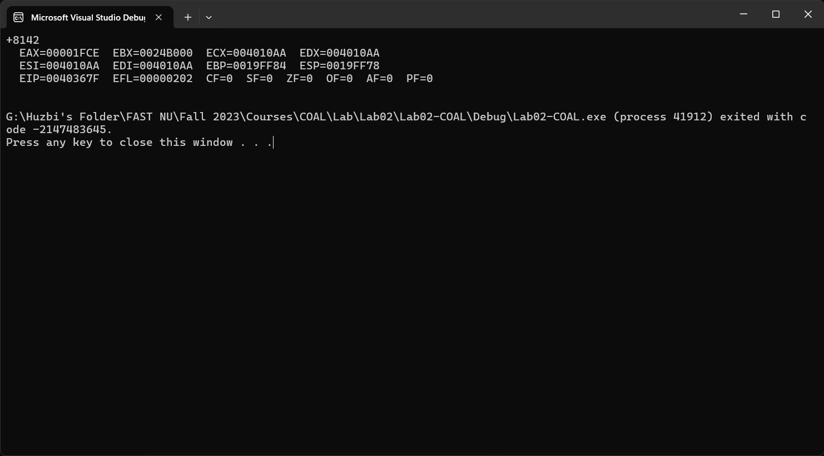

**REGISTER VALUES:**

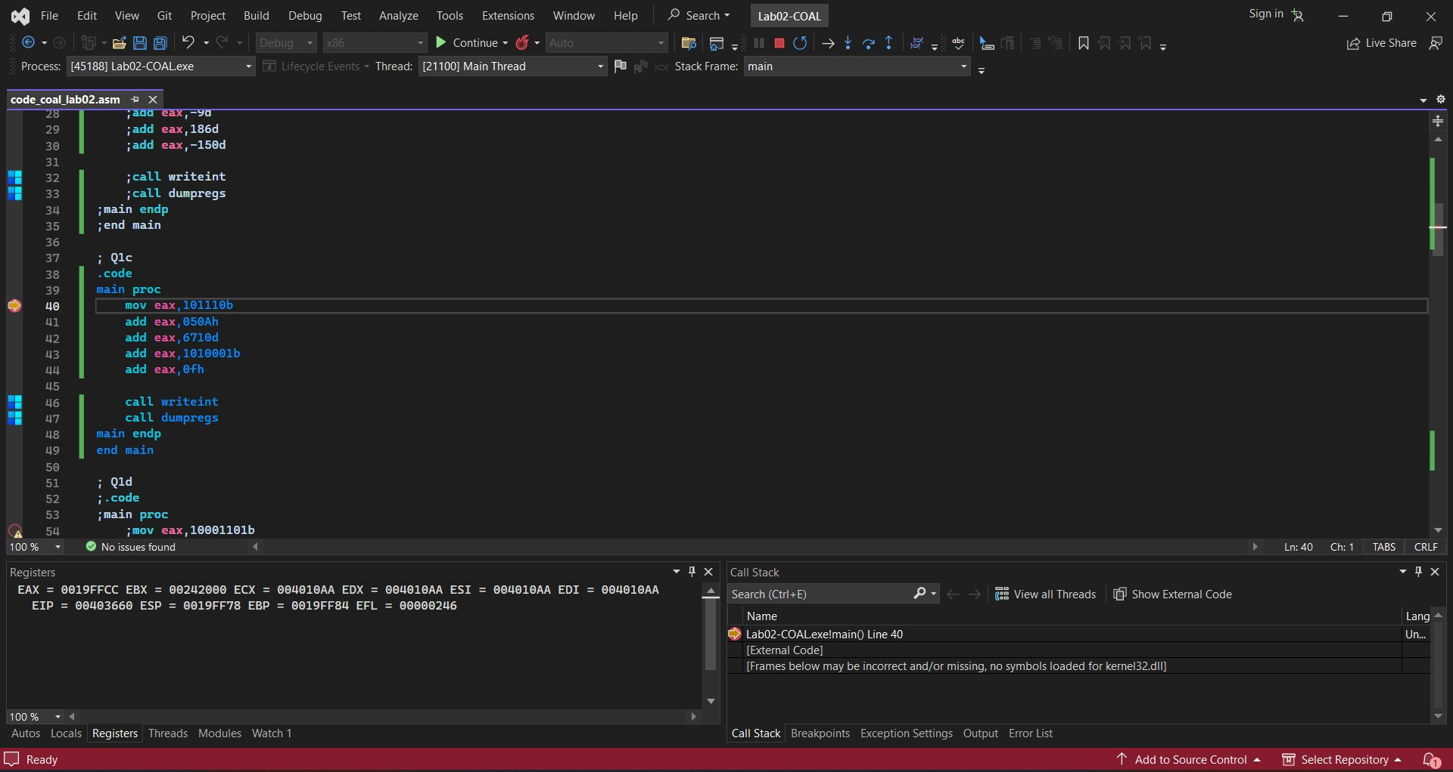

1. **CODE:**

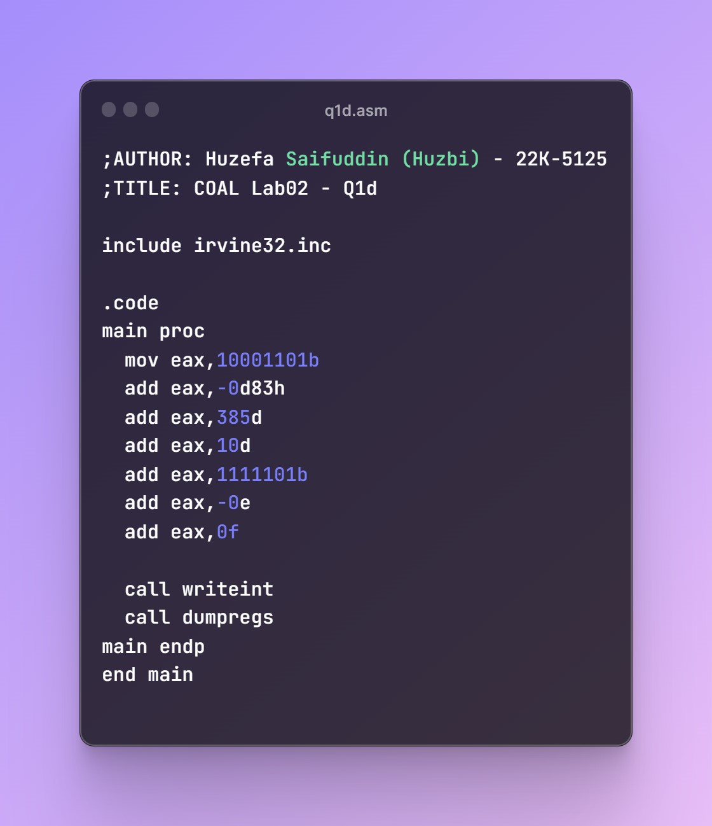

**OUTPUT:**

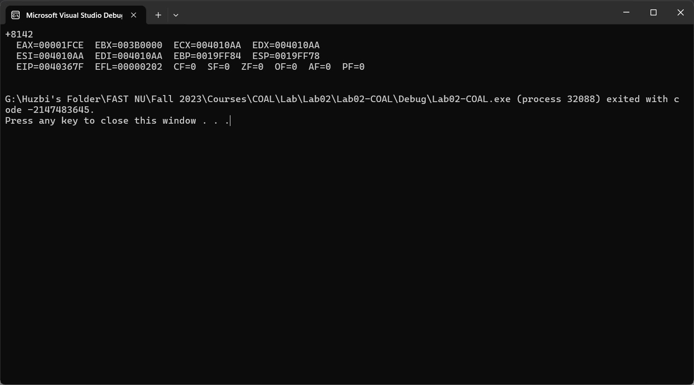

**REGISTER VALUES:**

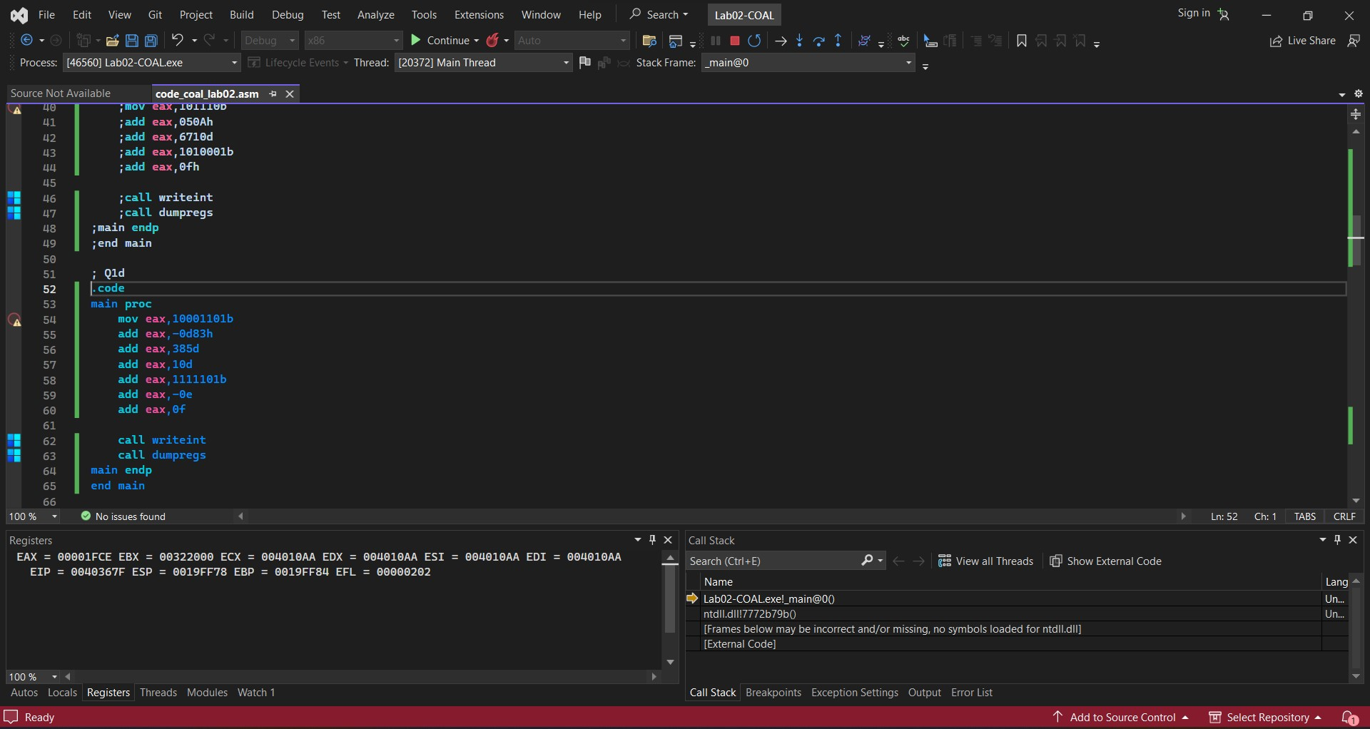

1. **CODE:**

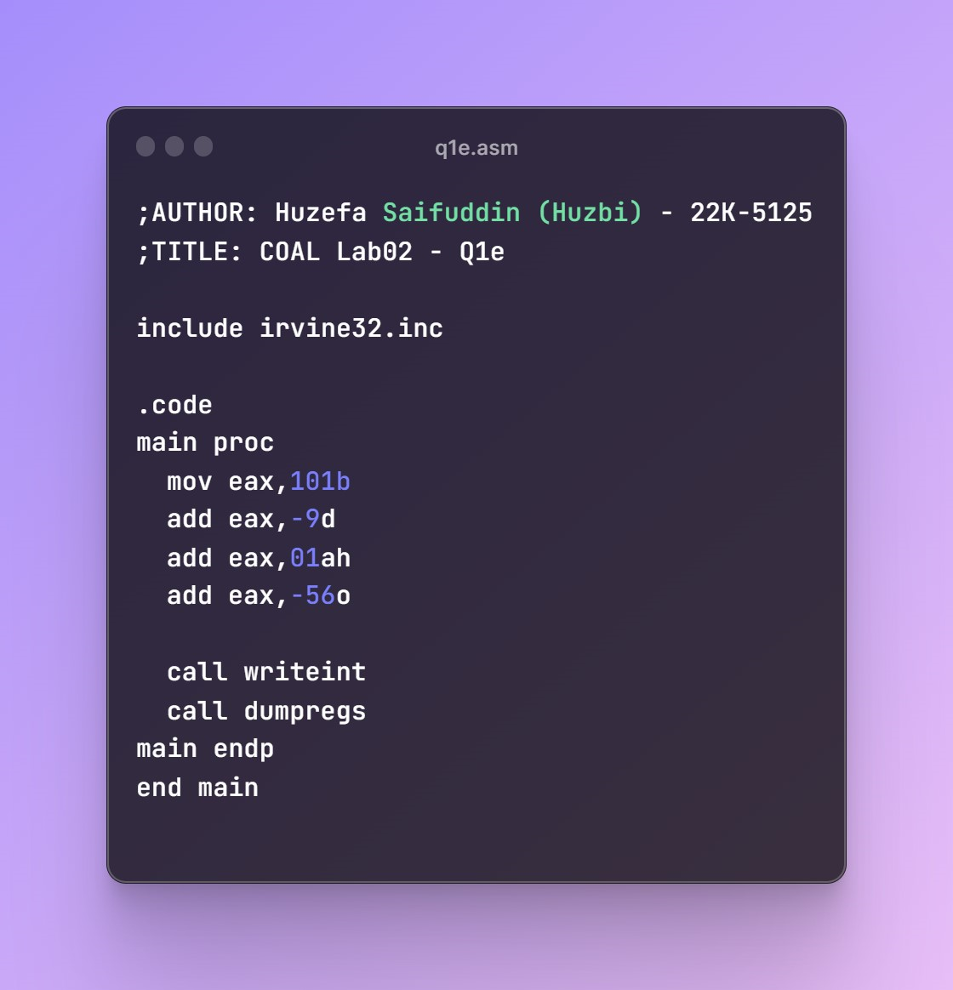

**OUTPUT:**

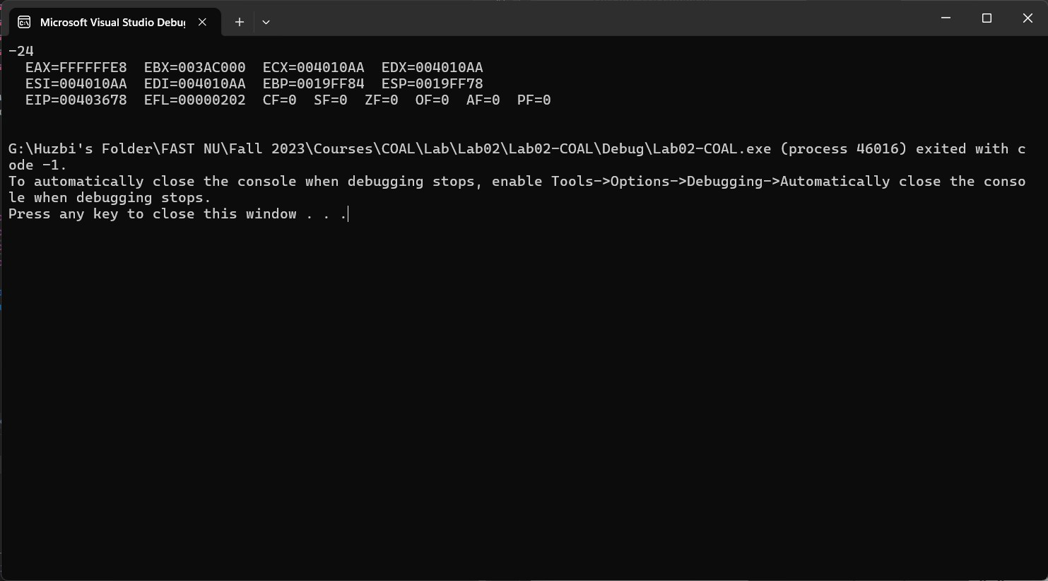

**REGISTER VALUES:**

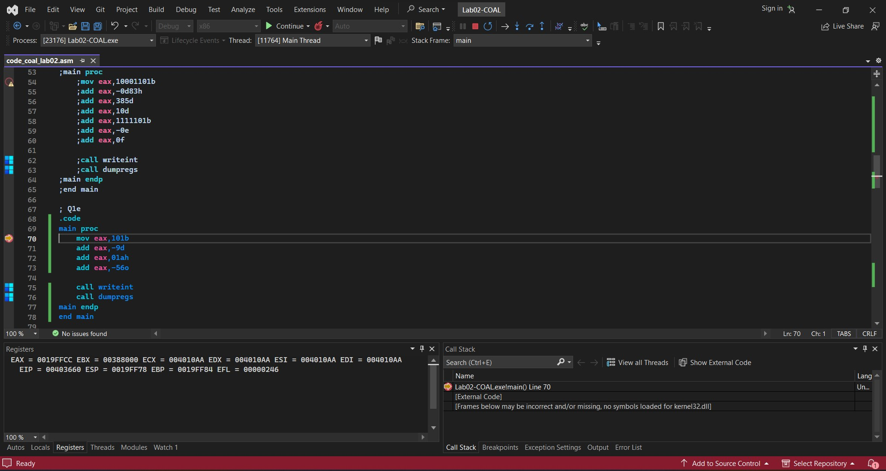

## QUESTION #2:

1. **CODE:**

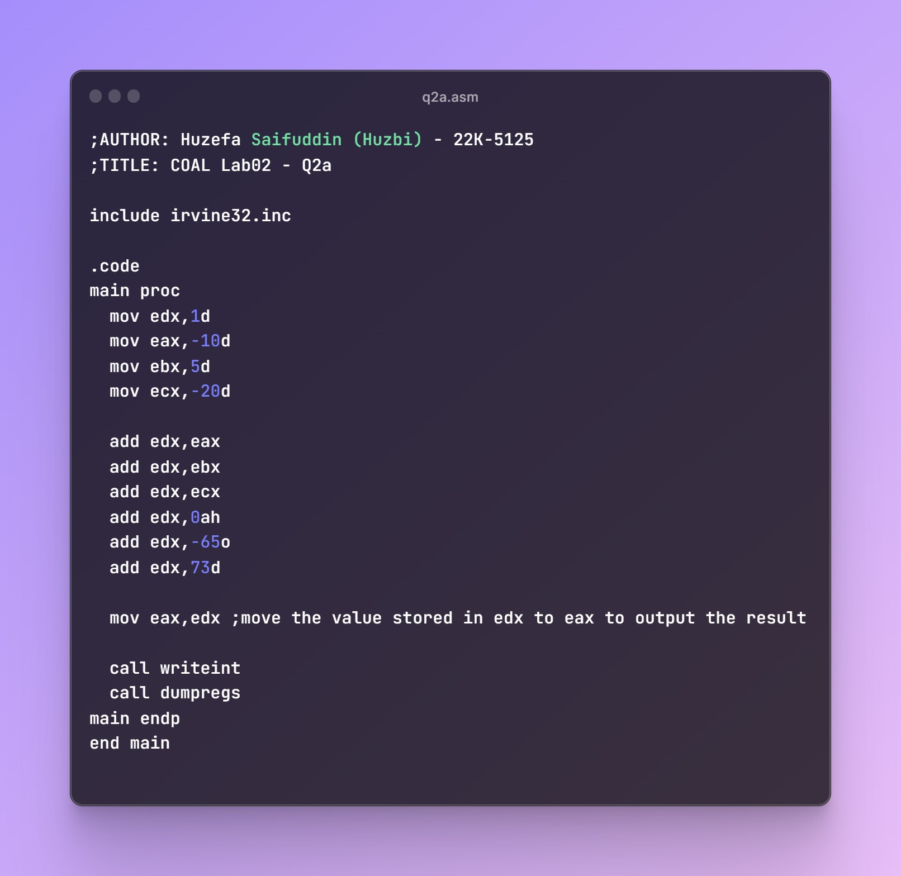

**OUTPUT:**

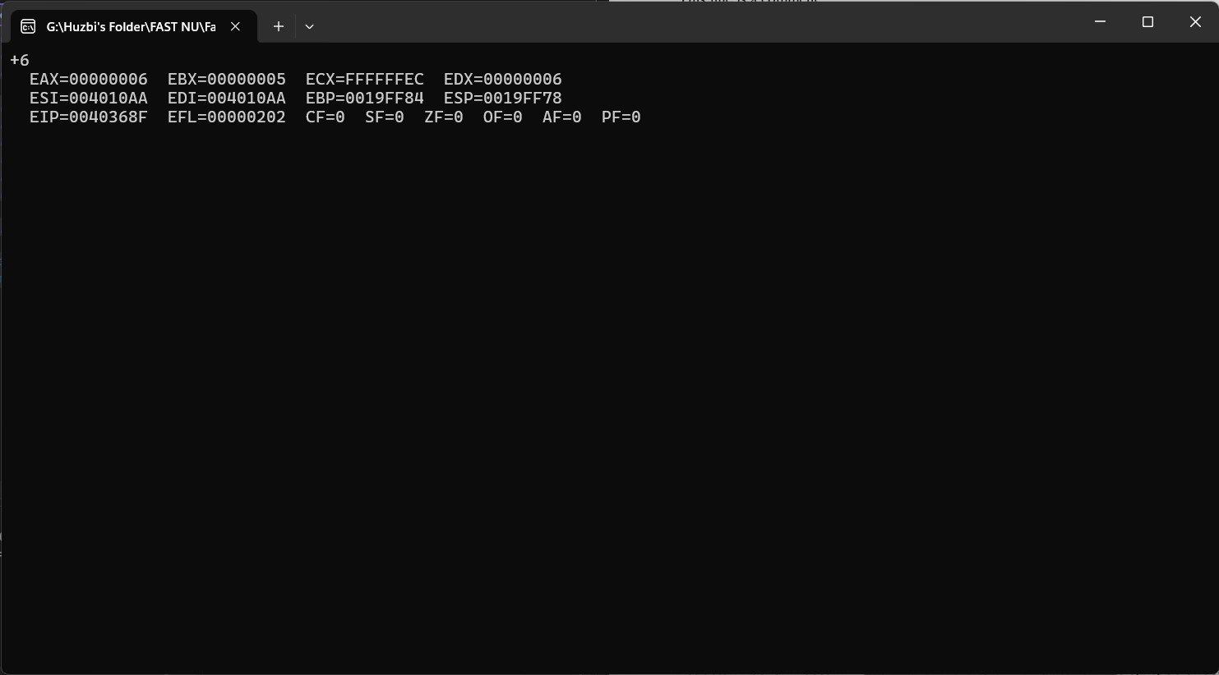

**REGISTER VALUES:**

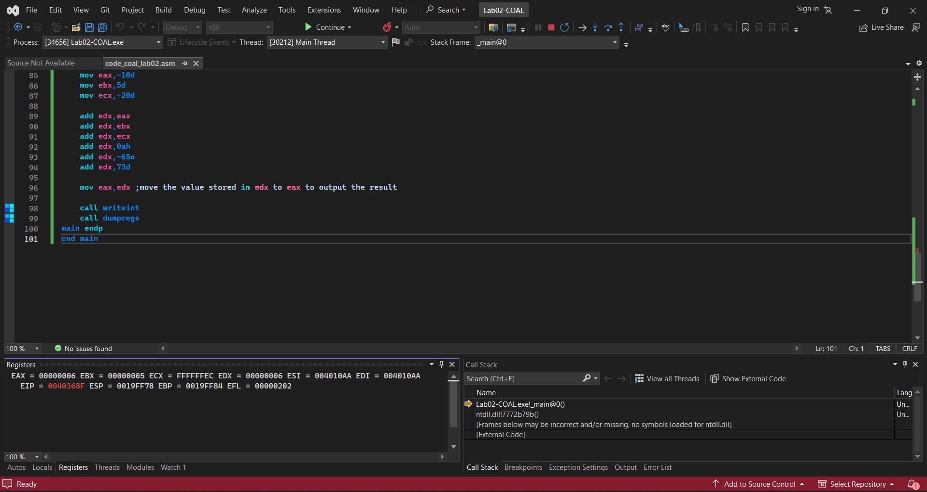

1. **CODE:**

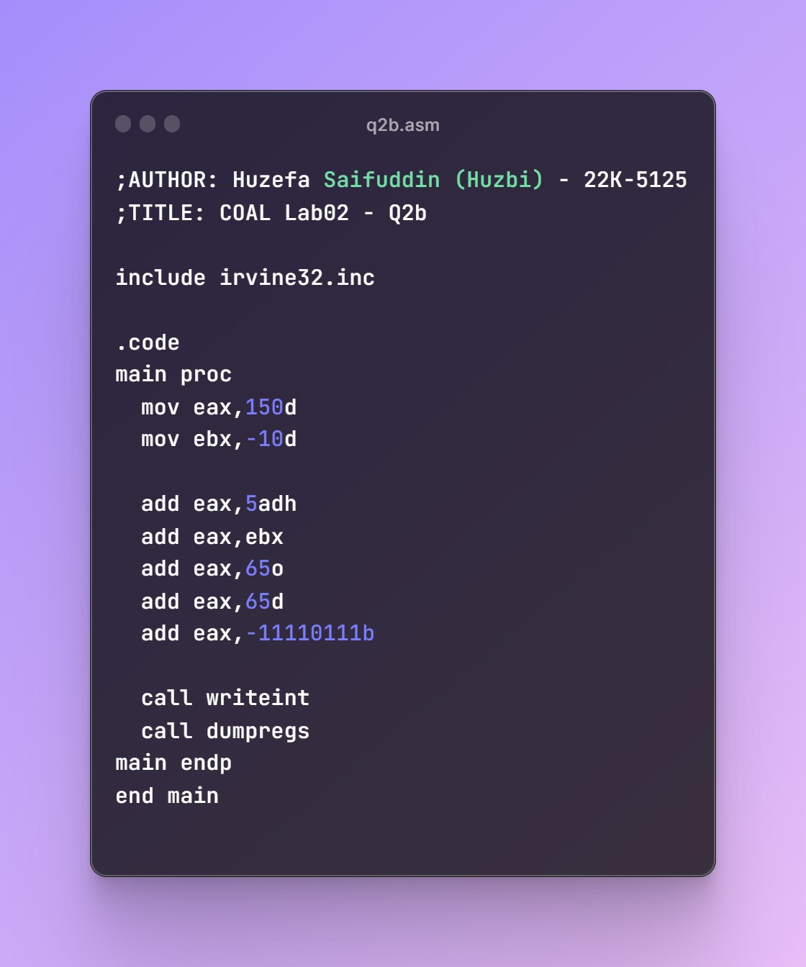

**OUTPUT:**

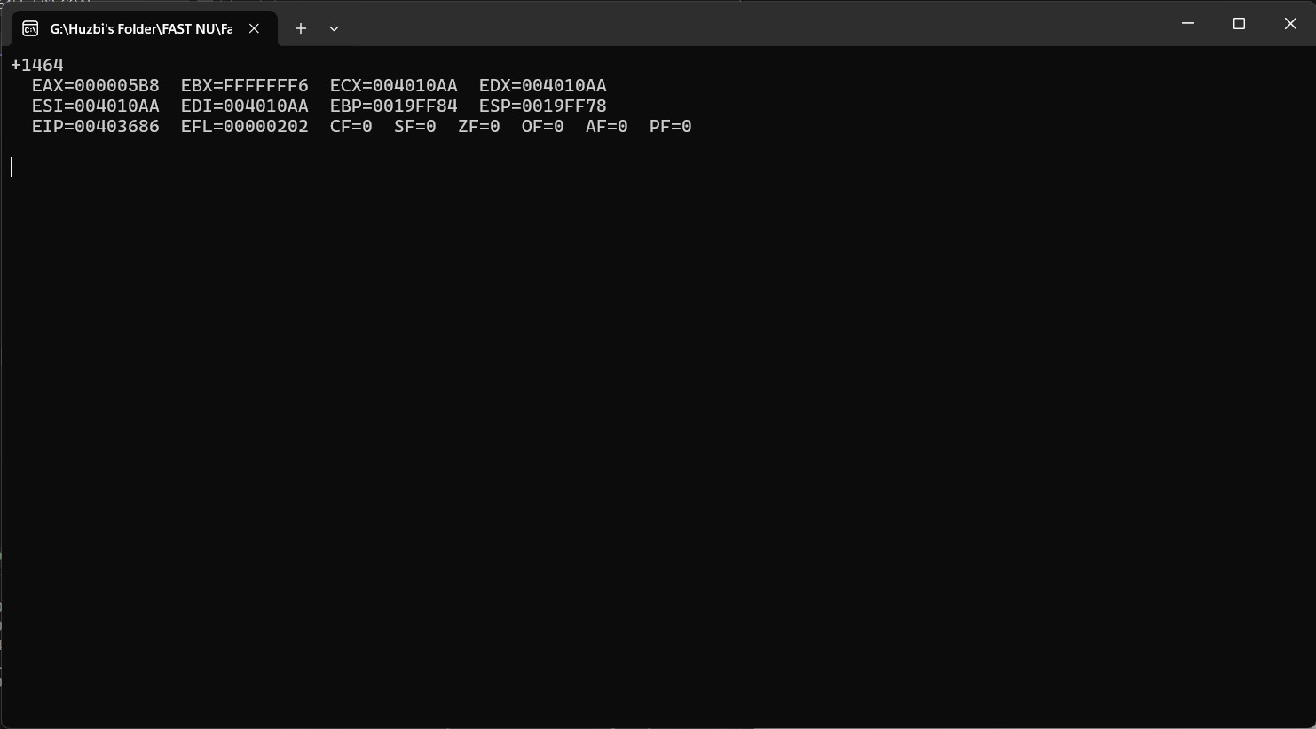

**REGISTER VALUES:**

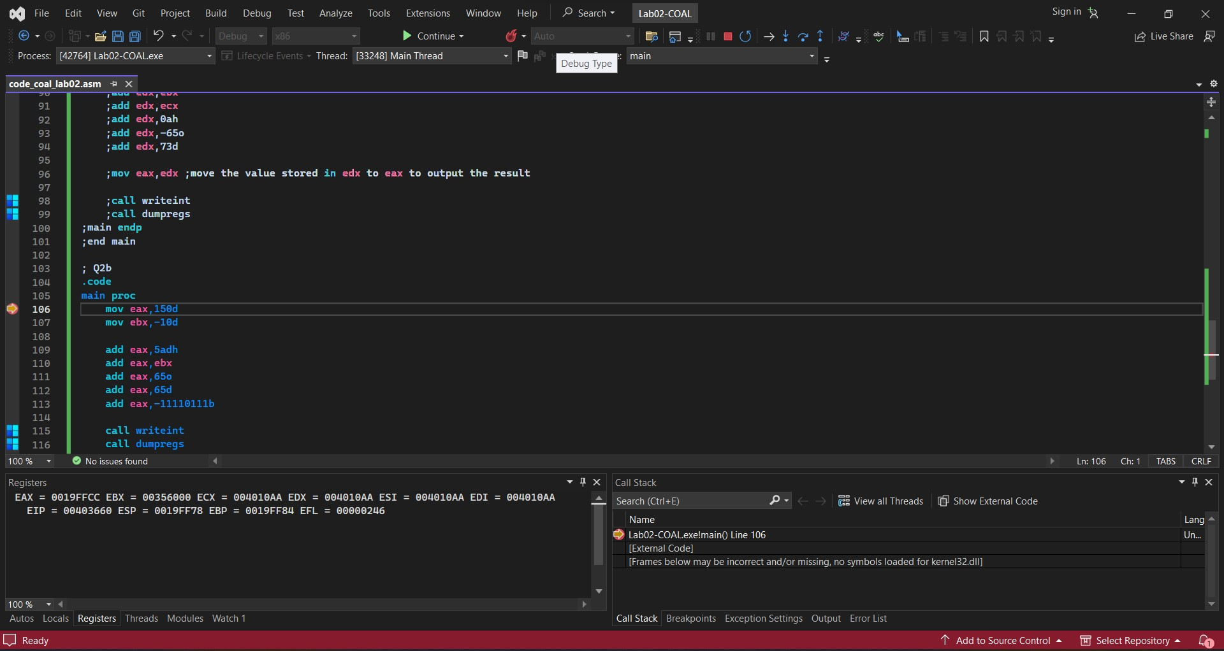

1. **CODE:**

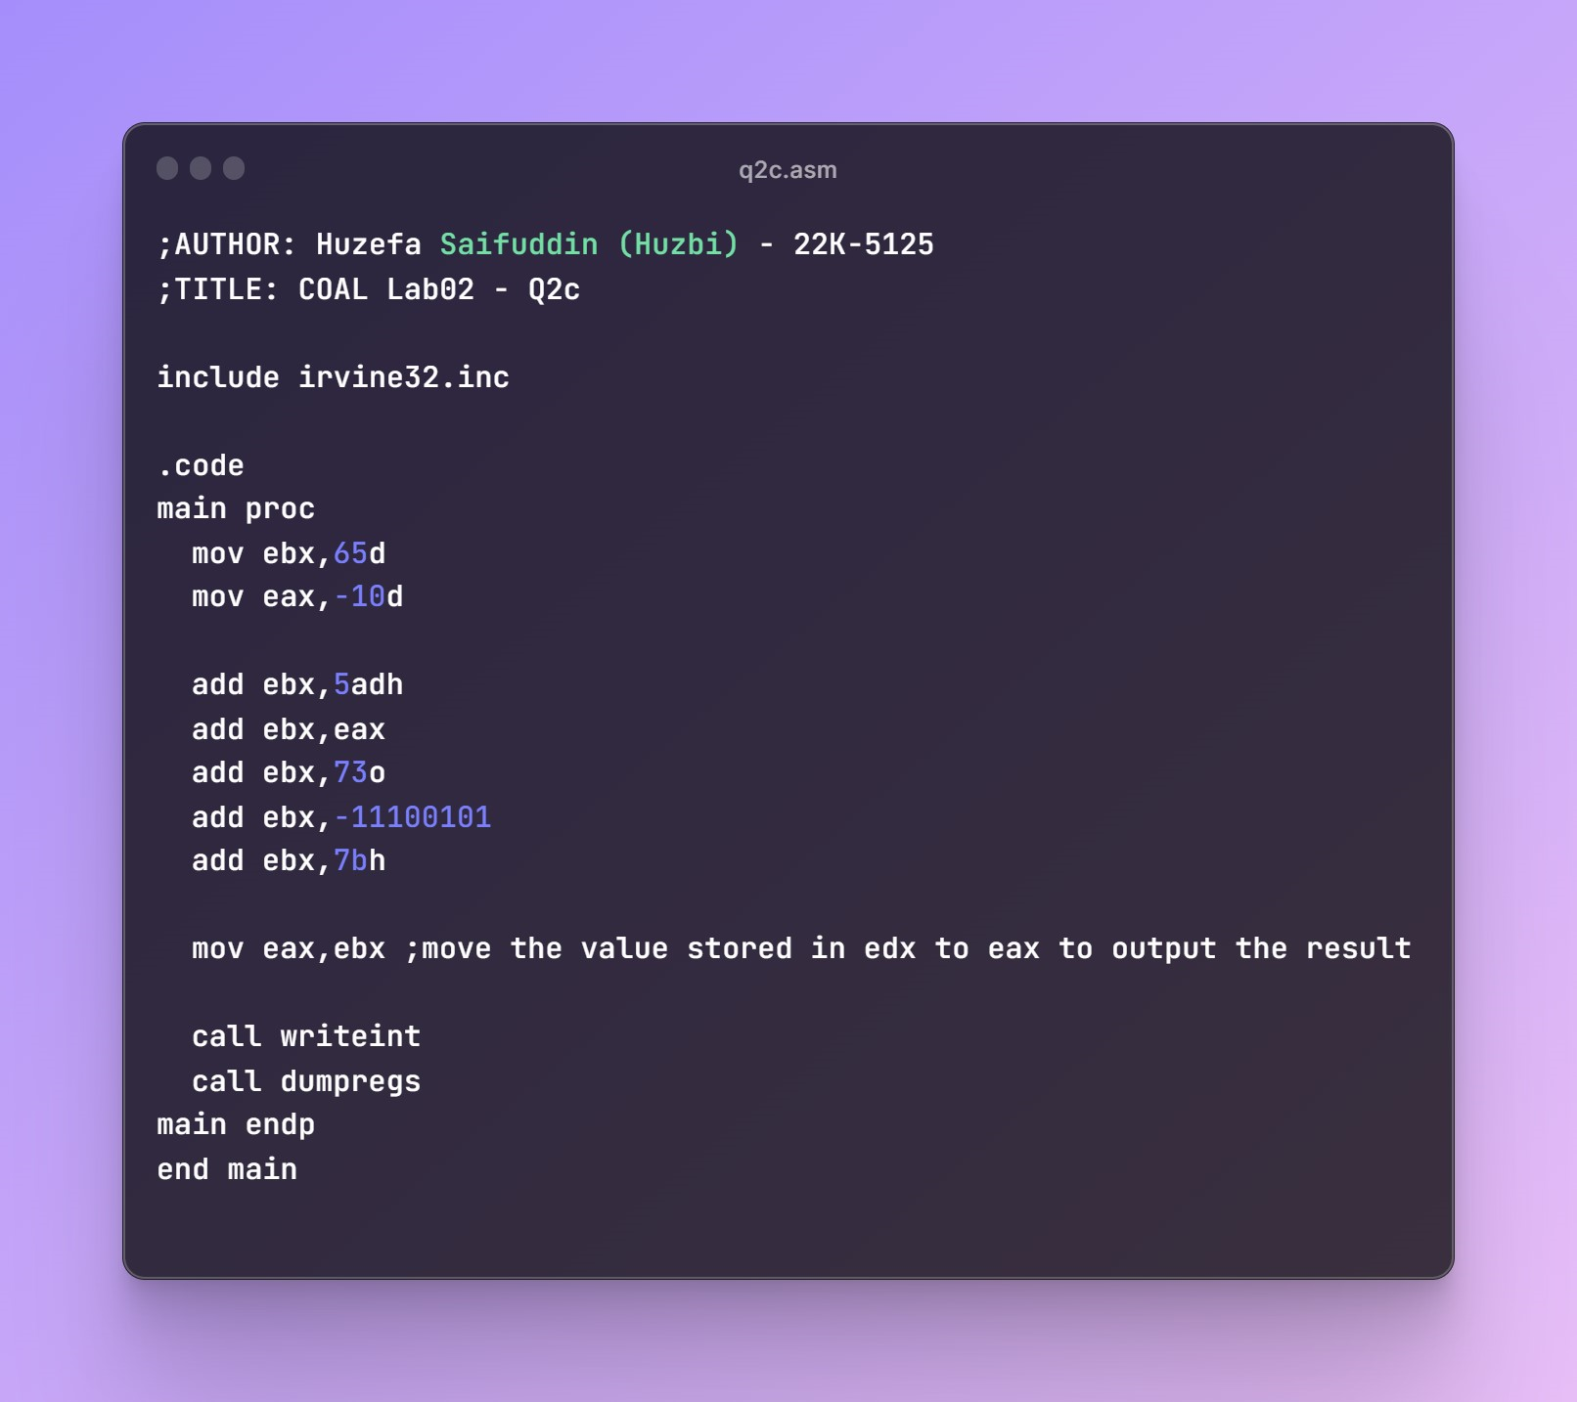

**OUTPUT:**

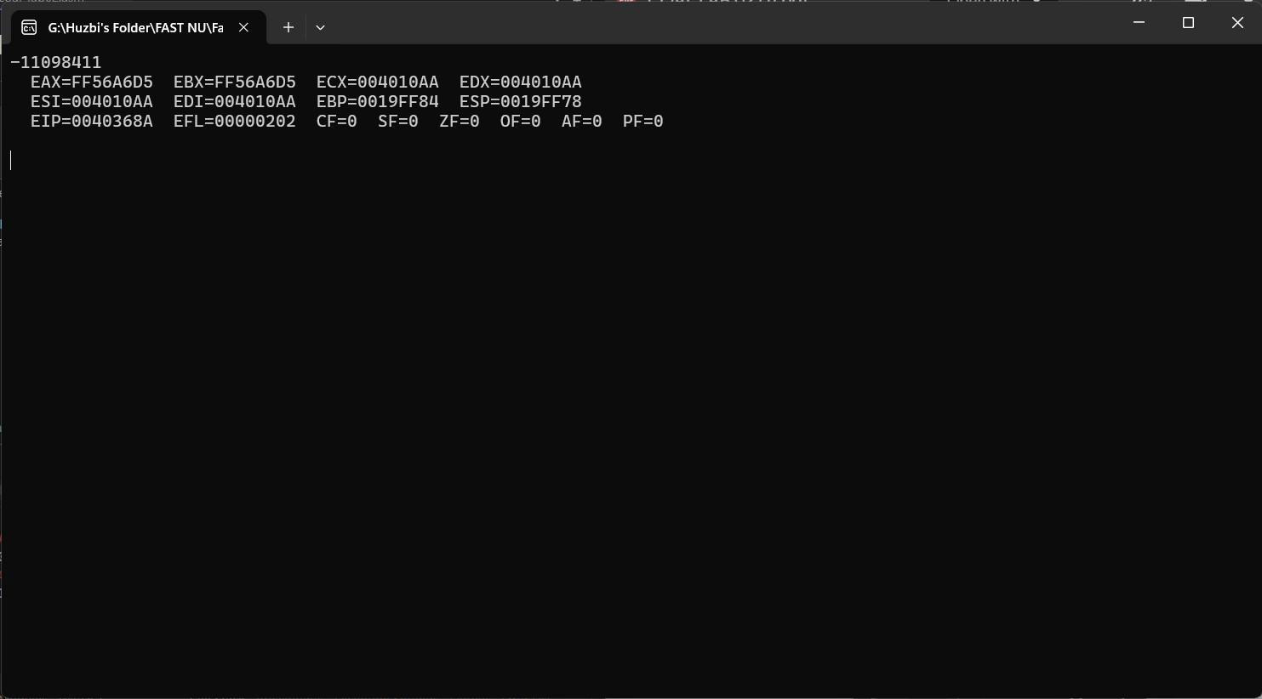

**REGISTER VALUES:**

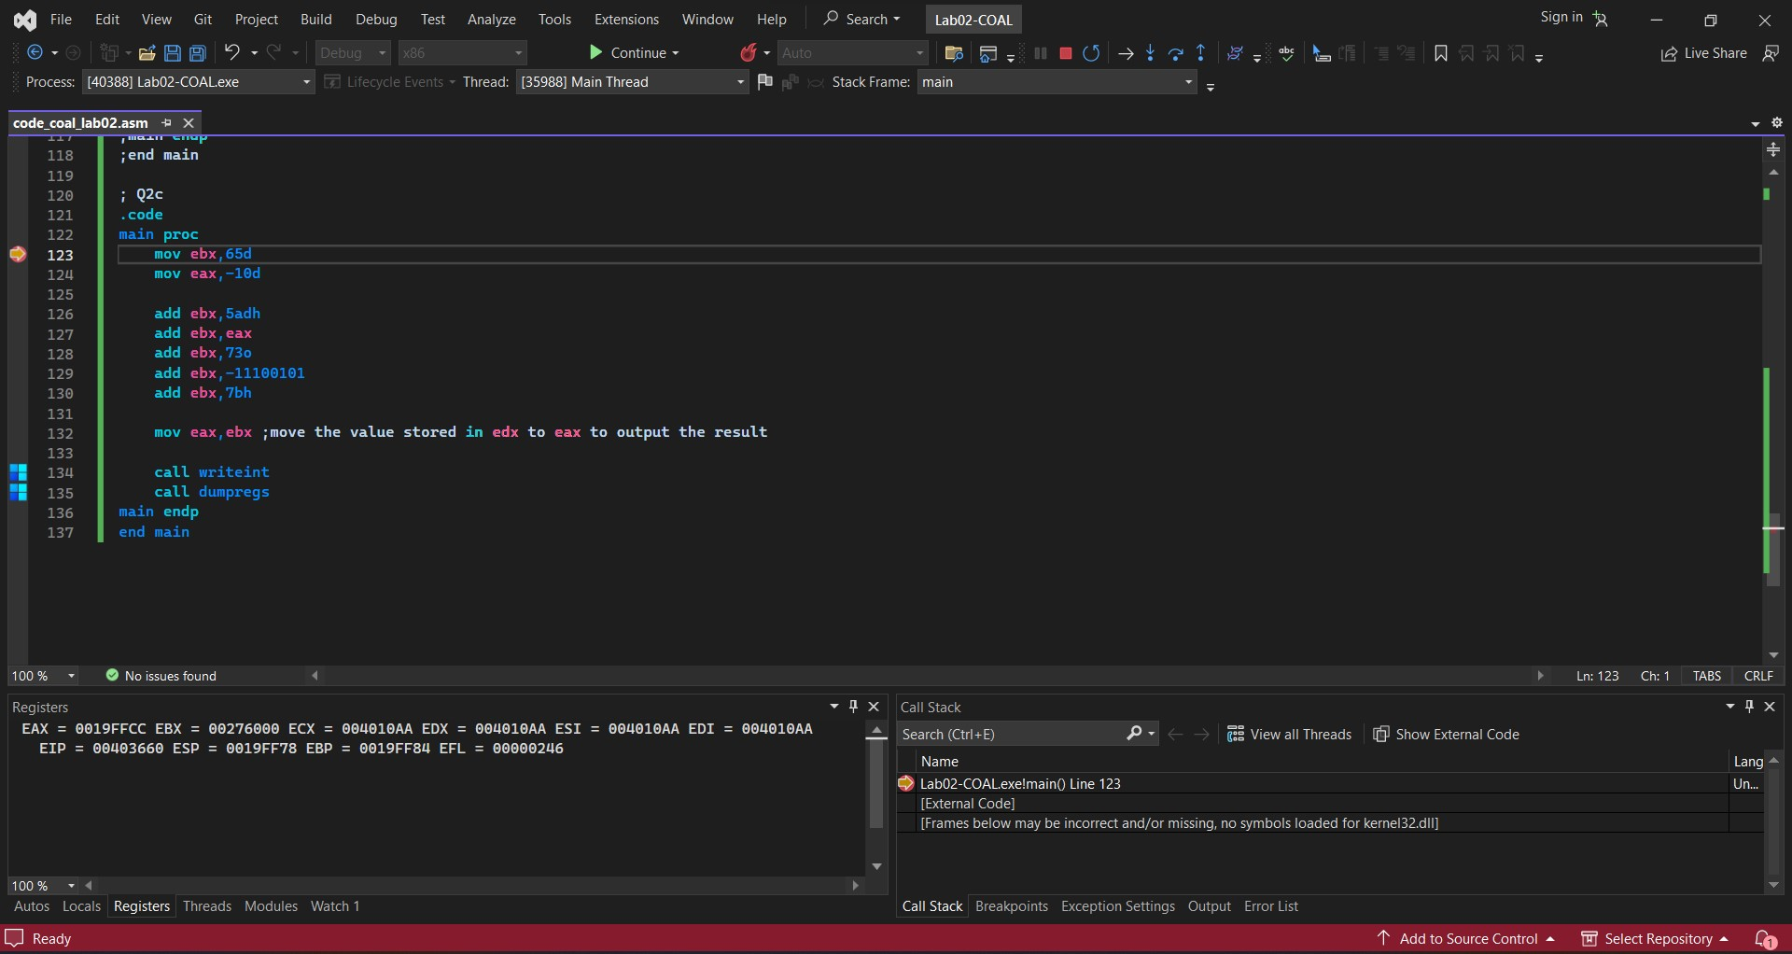

1. **CODE:**

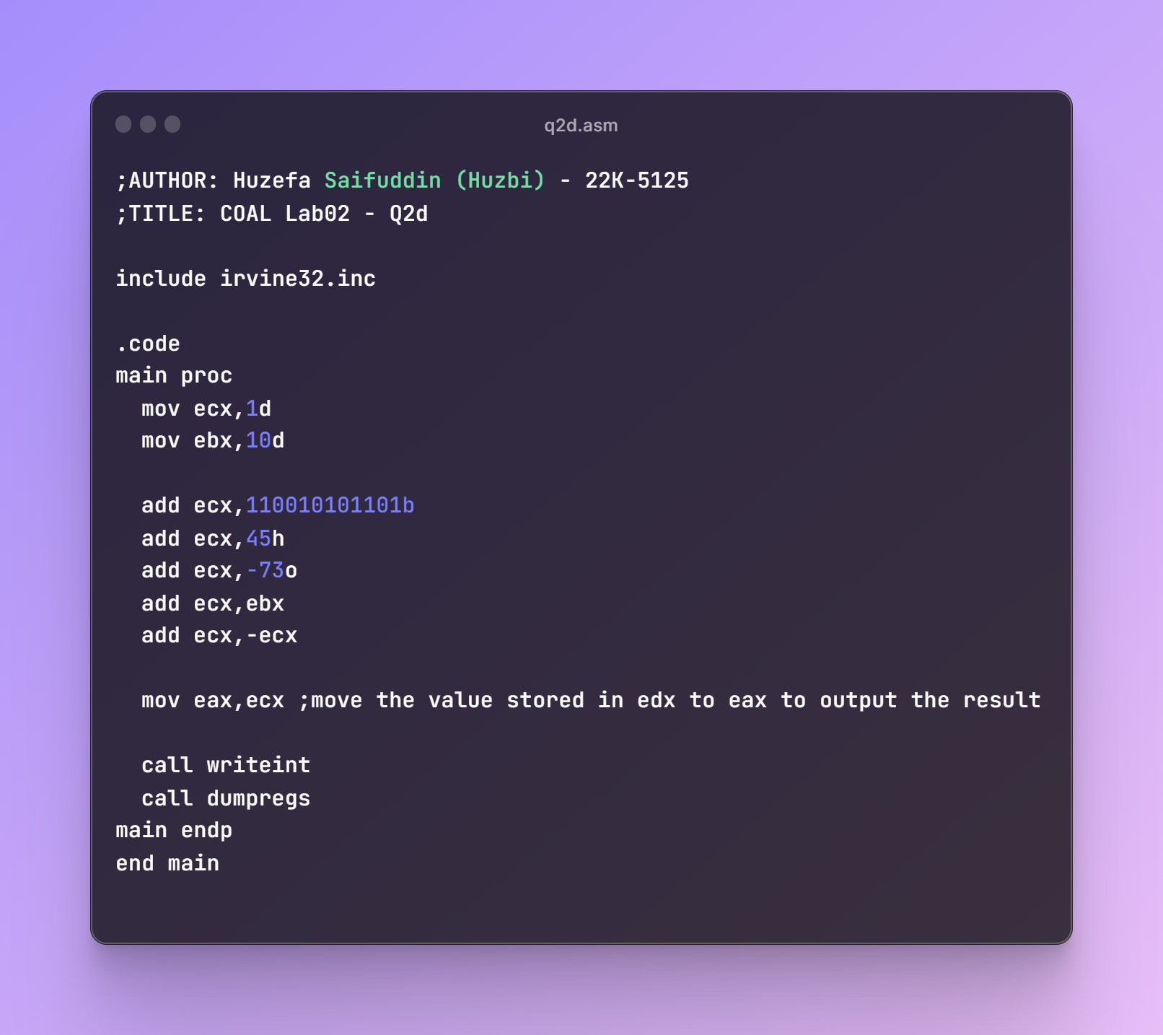

**OUTPUT:**

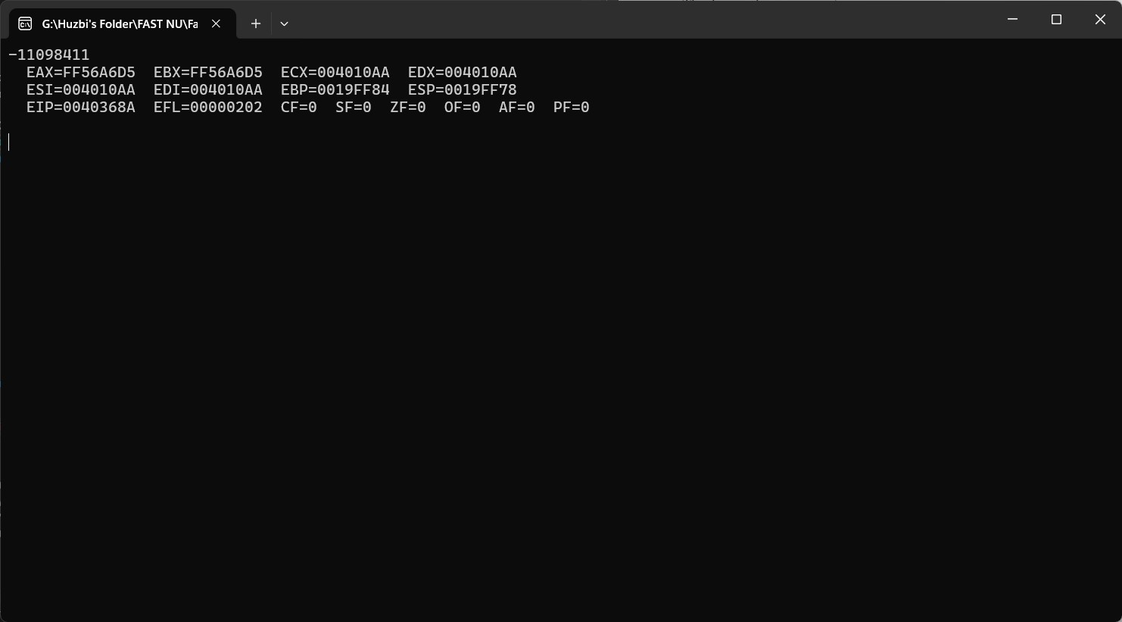

**REGISTER VALUES:**

